CS 340 README

About the Project/Project Title
This is a full-stack web dashboard built for Grazioso Salvare, an international rescue animal training company. The dashboard connects to a MongoDB database containing 10,000 records from the Austin Animal Center and lets users filter shelter animals by rescue type: Water Rescue, Mountain or Wilderness Rescue, and Disaster or Individual Tracking. Each filter narrows the data table to dogs that match specific breed, sex, and age criteria that Grazioso Salvare uses to identify good search-and-rescue candidates. The dashboard also includes a pie chart that updates to show the breed distribution of filtered results and a geolocation map that pins the selected animal on a map of Austin, Texas. It was built using the CRUD Python module from Project One and the Dash framework introduced in Module Five.

Motivation
Grazioso Salvare needed a way to quickly scan thousands of shelter records and pull out dogs that fit their training profiles. Doing this manually or running raw MongoDB queries every time is not practical. This dashboard puts a visual interface on top of the database so that non-technical staff can click a radio button and immediately see which animals are available, where they are located, and what breeds are represented. I built it for CS 340 at SNHU as the capstone project, pulling together the CRUD module from Project One, the Dash framework from Module Five, and the data table and map widgets from Module Six.

Getting Started
You need a running MongoDB instance with the AAC dataset loaded and an authenticated user account. The setup has two parts: importing the CSV data and creating a database user with the right permissions. Both of these were completed in earlier modules (Module Three for the database and user setup, Module Four for the CRUD module).

Database Setup
The AAC shelter outcomes CSV was imported into the aac database using the mongoimport tool. The command specifies the database name (aac), collection name (animals), file type (csv), and uses the --headerline flag to treat the first row of the CSV as field names. The --drop flag clears any existing data in the collection before import to avoid duplicates.
mongoimport --db aac --collection animals --type csv --headerline --drop ./aac_shelter_outcomes.csv

User Authentication
The aacuser account was created in the admin database with a readWrite role scoped to the aac database. This way the account only has the permissions it needs for CRUD operations on the shelter data, nothing more.

Installation
MongoDB (v7.0) is the database server. It stores data in JSON-like documents (BSON), which is a good fit for the AAC dataset since the records have a lot of different fields and the schema can vary between documents. Python 3 is used for both the CRUD module and the dashboard code. PyMongo is the driver that lets Python talk to MongoDB. I went with PyMongo because it is the officially supported driver from MongoDB and maps pretty directly to the shell commands I already knew (find, insert_one, update_many, delete_many). Dash by Plotly is the web framework that provides the view and controller structure using Python callbacks instead of requiring JavaScript. Plotly Express handles the pie chart, and dash_leaflet handles the geolocation map. Jupyter Notebook runs the dashboard since the starter code uses JupyterDash. All of these come pre-installed in the Codio environment, but they can also be installed with pip:
pip install pymongo dash jupyter-dash dash-leaflet plotly pandas numpy.

Tools Used and Rationale

MongoDB was used as the model component because it handles semi-structured data well. The AAC dataset has fields that vary between records, and MongoDB does not require a fixed schema. Its query language supports the compound filters needed for rescue type lookups (matching on breed, sex, and age range in a single query using $in and $gte/$lte operators). It also interfaces cleanly with Python through PyMongo, which returns documents as dictionaries that convert directly into Pandas DataFrames.

Dash by Plotly provides the view and controller structure for the web application. It uses a callback system where Python functions run automatically when a user interacts with a widget. This keeps all the logic in Python without needing to write separate JavaScript or HTML. The MVC pattern maps naturally: MongoDB is the model, the CRUD Python module is the controller glue (using Pandas to bridge between MongoDB documents and Dash components), and the Dash layout is the view.

Plotly Express was used for the pie chart because it integrates directly with Dash and accepts Pandas DataFrames as input. dash_leaflet was used for the geolocation map because it provides interactive OpenStreetMap tiles with marker support. Pandas bridges the gap between MongoDB cursor output and the DataTable/chart components.

Resources accessed: Dash Documentation (https://dash.plotly.com), Dash Core Components reference, MongoDB PyMongo documentation, CS 340 Dashboard Specifications Document, and the Module Six Dashboard Sample Walkthrough provided by the course

Usage

Code Example
The CRUD module is imported and instantiated with the MongoDB credentials. The dashboard uses the read method to pull data based on which filter is selected:
from CRUD_Python_Module import AnimalShelter
db = AnimalShelter("aacuser", "<password>")
df = pd.DataFrame.from_records(db.read({}))

Each rescue filter builds a MongoDB query with breed, sex, and age criteria. For example, the Water Rescue filter queries for Labrador Retriever Mix, Chesapeake Bay Retriever, or Newfoundland breeds that are Intact Female and between 26 and 156 weeks old. The query is passed to db.read(), the result is converted to a DataFrame, the _id column is dropped (required for MongoDB v5+ to prevent ObjectID crash in the DataTable), and the records are returned to update the dashboard

Tests
Testing followed the three-phase approach covered in Module Seven. Unit testing confirmed each filter query returns the correct breed and sex combinations by running the queries in the mongo shell and comparing results. Integration testing verified that selecting a radio button triggers the callback, updates the DataTable, refreshes the pie chart, and moves the map marker. Regression testing checked that applying one filter and then switching to another (or Reset) properly clears the previous results. The screenshots below demonstrate all four filter states working correctly

Screenshots
Below is the dashboard in the Reset (starting) state, showing the unfiltered data table, pie chart, and geolocation map with the Grazioso Salvare logo and unique identifier visible:
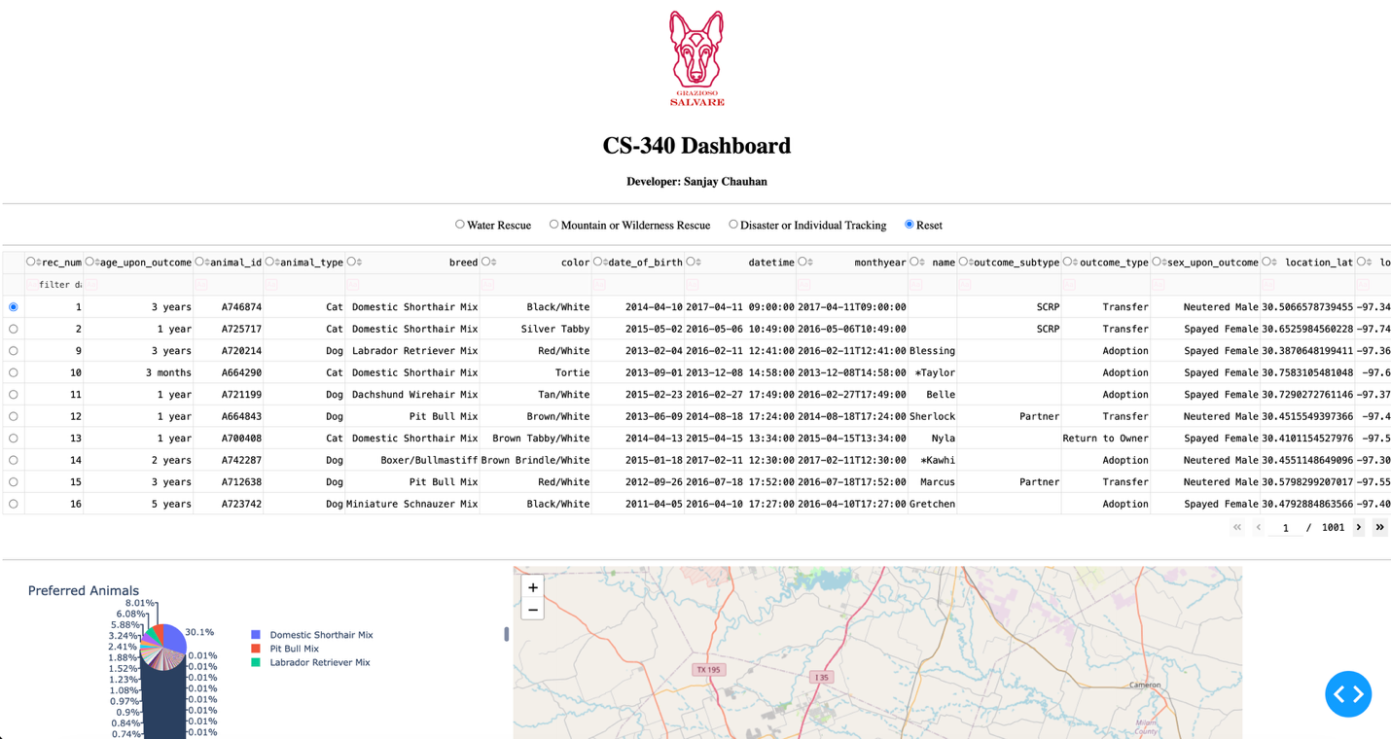
Below is the dashboard with the Water Rescue filter applied. The data table shows only Labrador Retriever Mix, Chesapeake Bay Retriever, and Newfoundland breeds that are Intact Female and 26-156 weeks old: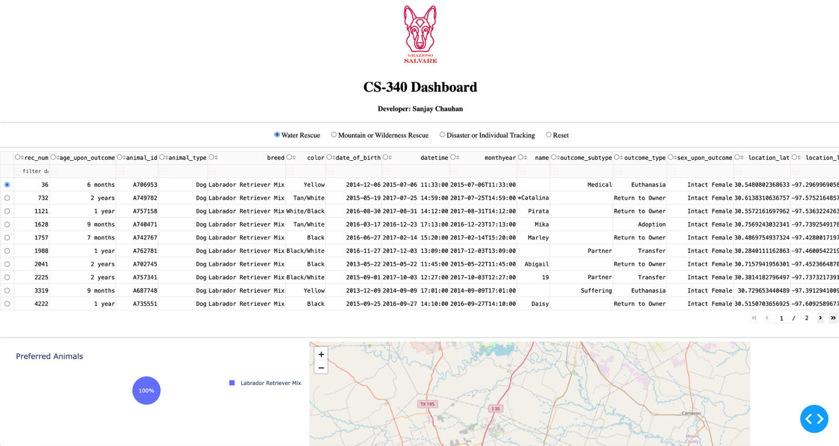

Below is the dashboard with the Mountain or Wilderness Rescue filter applied. The data table shows German Shepherd, Alaskan Malamute, Old English Sheepdog, Siberian Husky, and Rottweiler breeds that are Intact Male and 26-156 weeks old:
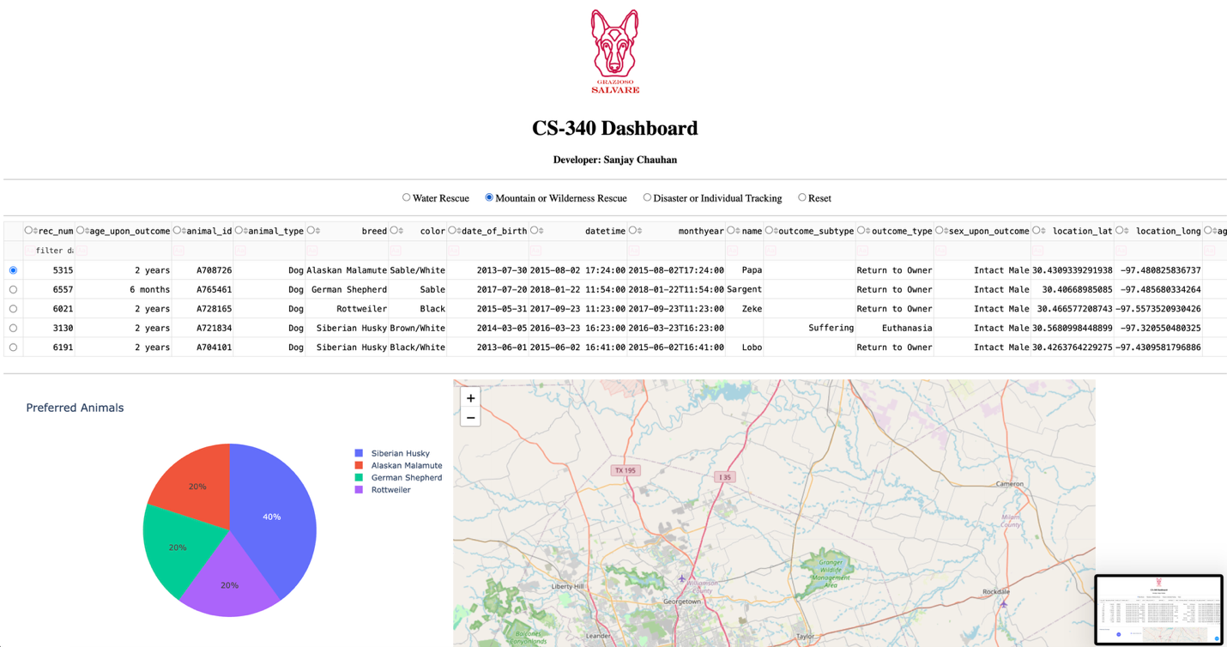
Below is the dashboard with the Disaster or Individual Tracking filter applied. The data table shows Doberman Pinscher, German Shepherd, Golden Retriever, Bloodhound, and Rottweiler breeds that are Intact Male and 20-300 weeks old:

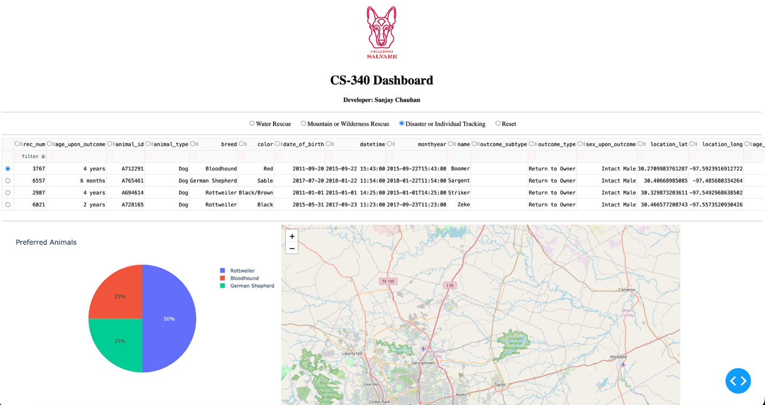
Challenges

One issue I ran into was that the aacuser account had been created in a previous Codio session with a different password, so authentication kept failing with an OperationFailure error. I fixed it by opening the mongo shell, switching to admin with 'use admin', dropping the old user with db.dropUser('aacuser'), and recreating it with the right password using db.createUser(). After that it connected on the first try.

Another issue was the _id column from MongoDB v5+. The ObjectID type causes the Dash DataTable to crash because it cannot serialize it to JSON. The fix was to drop the _id column from the DataFrame after every query, including inside the update_dashboard callback (not just at initial load).

Contact
Sanjay Chauhan

